Google project documentation

1. **ASK**

What is the problem you are trying to solve?

Bellabeat, a company that creates health and wellness-focused smart devices, is aiming to enhance its marketing strategy by leveraging current trends in smart device usage. The goal is to align these trends with the preferences and needs of Bellabeat’s customer base. By doing so, Bellabeat aims to strengthen its brand positioning improve customer engagement, ultimately drive business growth.

How can your insights drive business decisions?

The insights derived from analyzing smart device usage trends can serve as a compass guiding Bellabeats’s business decisions. By aligning products, marketing, and strategies with these insights, Bellabeat can enhance customer satisfaction, drive growth and stay ahead in a rapidly evolving market.

* 1. **Business Task Statement:**

Analyze current trends in smart device usage to identify their potential application for Bellabeat customers and determine how these trends can be leveraged to shape and enhance the Bellabeat marketing strategy.

**1.3 Business Objectives:**

1. What are the trends identified?
2. How could these trends apply to Bellabeat customers?
3. How could these trends help influence Bellabeat marketing strategy?

**1.4 Deliverables:**

* A clear summary of the business task
* A description of all data sources used
* Documentation of any cleaning or manipulation of data
* A summary of analysis
* Supporting visualizations and key findings
* High-level content recommendations based on the analysis

**1.5 Key Stakeholders:**

* Urška Sršen: Bellabeat’s cofounder and Chief Creative Officer
* Sando Mur: Mathematician, Bellabeat’s cofounder and key member of the Bellabeat executive team
* Bellabeat marketing analytics team: A team of data analysts guiding Bellabeat's marketing strategy.

1. **Prepare**

The data is extracted from Kaggle and contained 18 datasets and contained one that combined all of the data.

The data is stored in an Excel sheet.

The data is in the long format.

**Data ROCCC:**

1. Reliable-The data is not reliable as it contained only 33 unique entries
2. Original-The originality of data is low as it is from the third party website
3. Comprehensive-The data is comprehensive but doesn’t contain enough data for in-depth analysis
4. Current-The data is collected in the year 2016 so it is not a current dataset
5. Cited- It is unknown as it is from the third party
6. **process**

**Data cleaning steps :(Using Python)**

1. Checked for null values. The dataset did not contain any null values
2. Checked for the data type of the columns and changed the data type of **“ActivityDate”** from object to **datatime** format.
3. Generated a variable called “unique_id” to know the individual ids of people.
4. Included new columns **“DayoftheweeK**”,”**TotalExerciseHours”**,**”TotalExerciseMinutes ”**
5. For the **“Dayoftheweek**” columns the **“ActivityDate**” has been used to extract the day
6. For the “**TotalExerciseMinutes”** column the sum **of “FairlyactiveMinutes**”, **“LightlyactiveMinutes**”, **“VeryactiveMinutes**” and **“SedentaryMinutes’** are taken.
7. For the **“TotalExerciseHours**” column the **“TotalExerciseMinutes**” column got divided by 60 minutes.
8. **Analyze**
9. Analyzed the statistical measures like mean, median using describe function.
10. There are 33 unique entries in the dataset.
11. The maximum calories burned in when the Exercise hours is 15.
12. People tend to have burned more calories and have high active hours on Saturdays.
13. **Share**

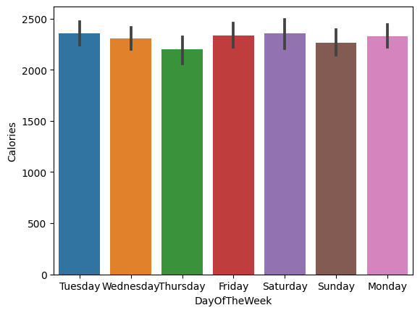

* Saturday has the highest calories burnt among Fitbit users

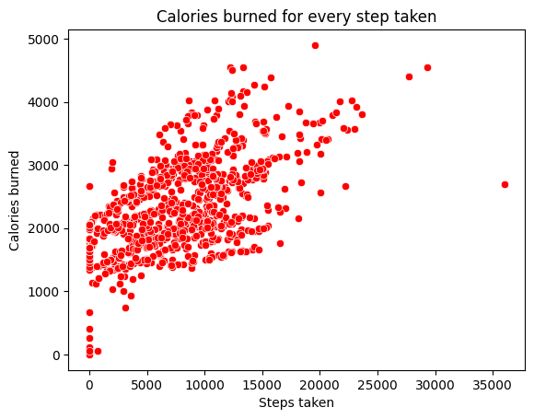

* Calories burned is directly proportional to the number of steps taken

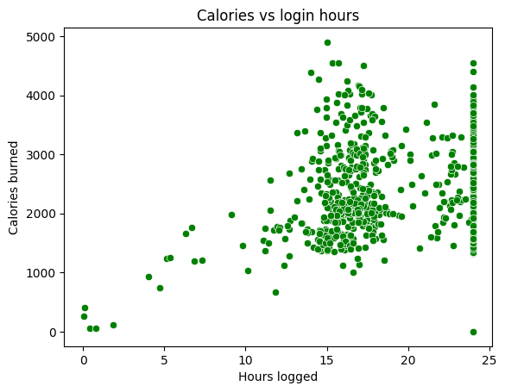

* Higher calories are burned when the hours logged is between 15 and 25 hours

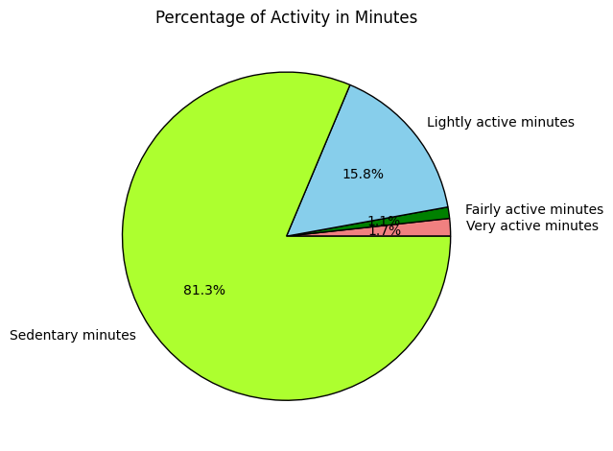

* Most people use the Fitbit Fitness Tracker for their sedentary minutes

1. **Act**

**Questions to answer**

1. What are some trends in smart device usage?

People tend to use the device more on sedentary rather than their active hours

People use the tracker app most on weekends.

1. How could these trends apply to Bellabeat customers?

As these are the general trends of the tracker device, these could apply to the users of their products and encourage them in building healthy habits with their products.

1. How could these trends help in Bellabeat marketing strategy?

Bellabeat can use these findings to improve their next product on creating easy environment for their habit tracking and awareness about the fitness.